Adventures to School: Real-Life Journeys of Students From Around the World
Teacher/Educator/Homeschool Resources
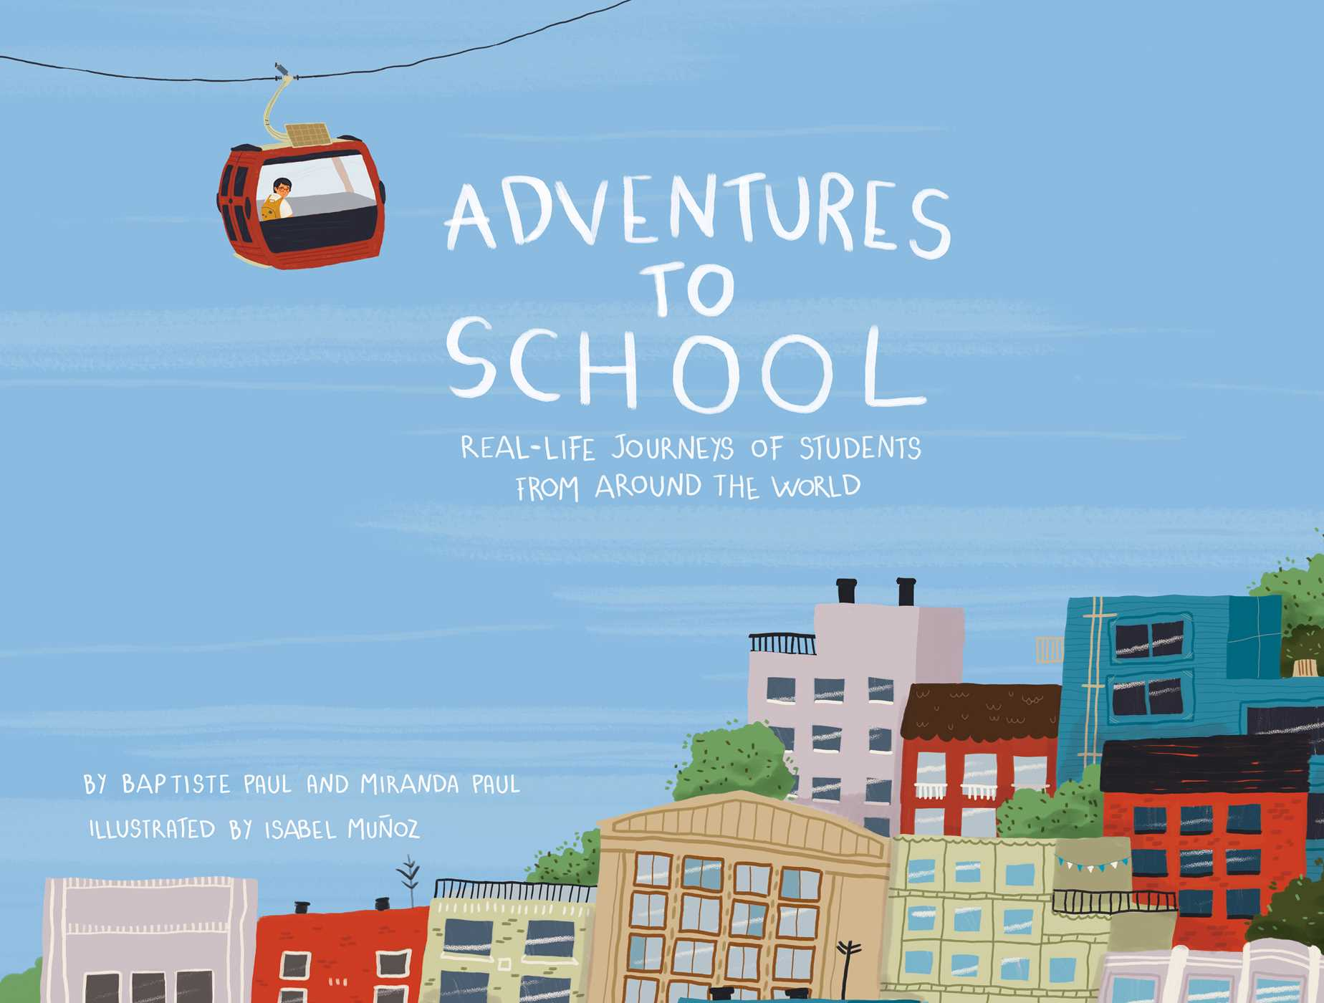
A picture book by Baptiste Paul and Miranda Paul, illustrated by Isabel Munoz, Published by Little Bee Books. Text Baptiste Paul and Miranda Paul.

Comprehension Objectives:
I can…
- Make connections
- Compare and contrast experiences
- Text to self
- Text to world
- Text to text
(Text suggestions: Water Princess by Peter H. Reynolds-Scholastic 2016, Schools Around the World by Donald Mitchell-Steck-Vaughn 1997)
- Ask and answer questions about key details

Essential Questions:
How did you get to school today?
Allow students 10 seconds of think time.
Turn and talk to carpet or table partners to compare and contrast.

Teacher may want to group students by similar modes of transportation to facilitate productive discussion throughout. Pairs or groups of four are suggested.

How might students in other countries get to school in similar or different ways?
Allow students 10 seconds of think time.
Turn and talk to carpet or table partners to compare and contrast.

Read the Story
Revisit essential questions with discussion throughout. Take time to turn and talk.
Think about how this student gets to school. How is this similar to your morning commute? How is it different? How is this student’s morning commute the same as the student from ___________? How is it different?

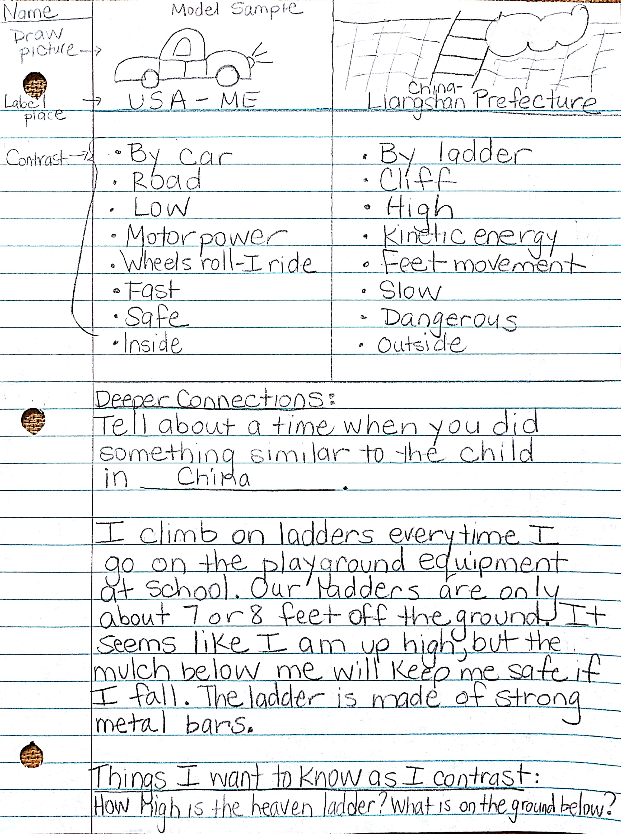
Students will be asked to contrast one experience from the story to their morning commute. They will also make deeper connections by explaining a similarity in complete sentences. This should produce further inquiry from the students. After, sharing in small groups will also facilitate more inquiry from additional students.

Teachers may want to share the following models with students prior to beginning self-work. Note: There are two models and templates to choose from for varied levels of students. The templates may be used for all comparisons: Text to self, Text to world, Text to Text

Name: EXAMPLE

Name: _______________________________

Picture Picture

Deeper Connections:
Tell about a time when you did something similar to the child in __________________.

Things I want to know as I contrast:

Early Learners Sample
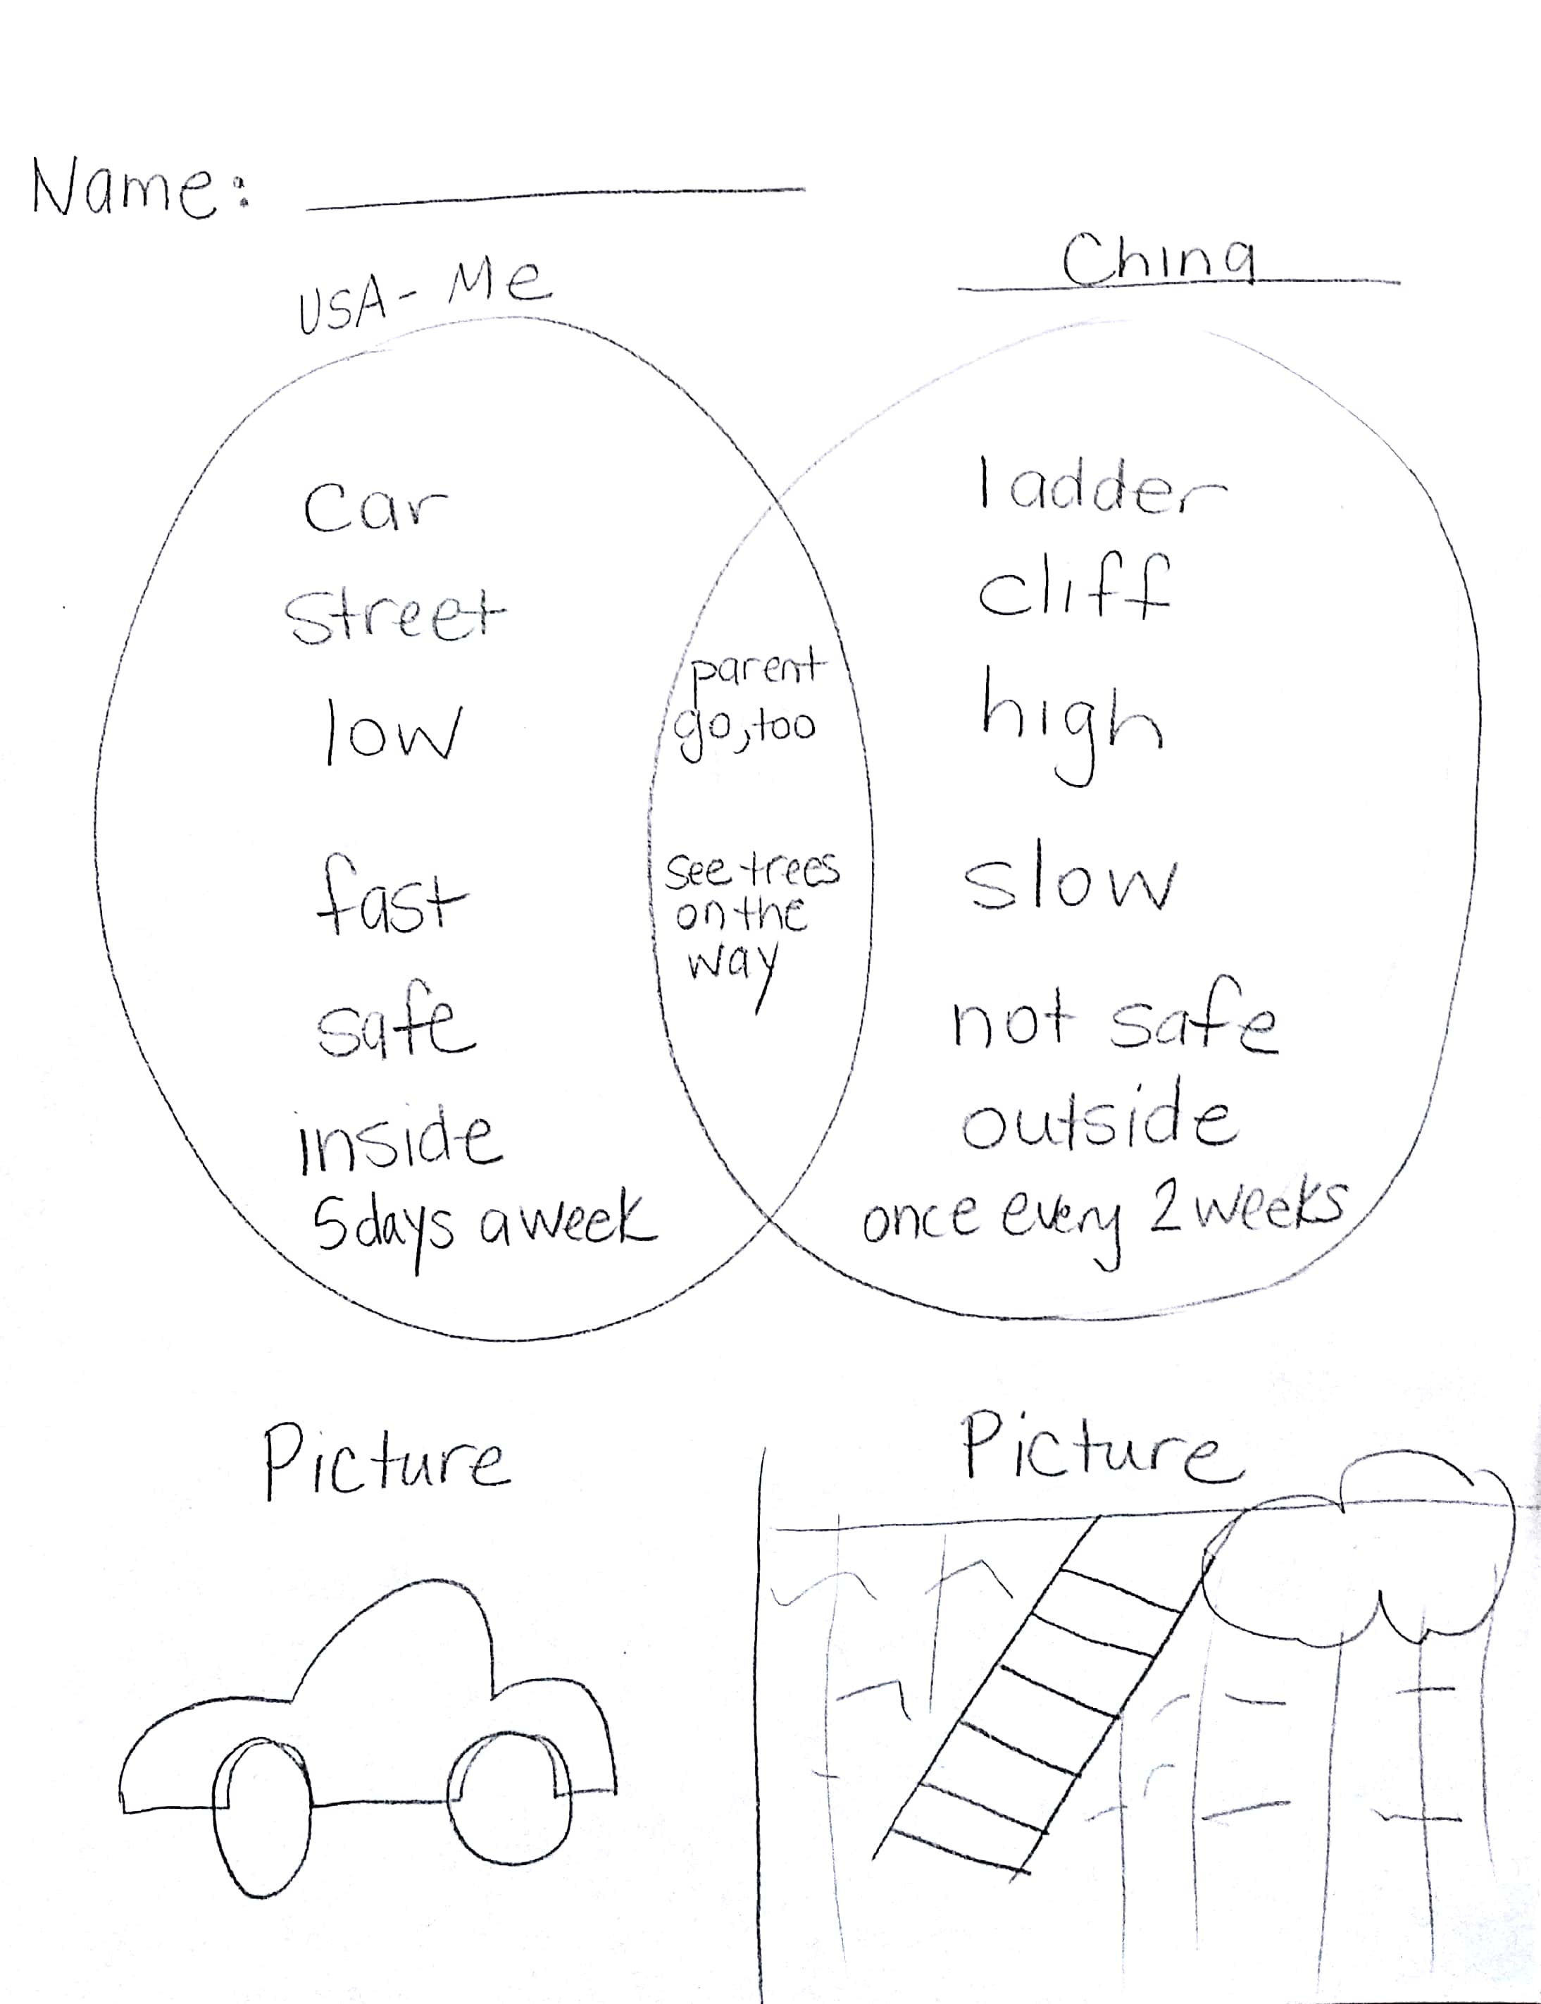

Name:_________________________________

Picture Picture

